

COS 330 Practical 3

By Dylan Kapnias (u18108467)



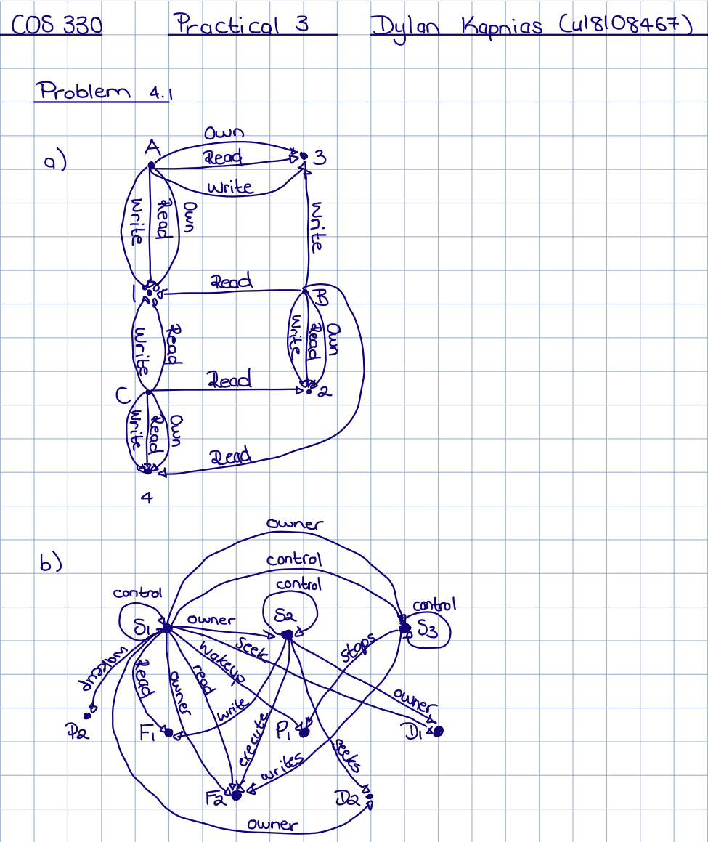

c) Yes, due to there being one line per access right, we have the ability to map each access right in the matrix to its corresponding access right in the digraph.

**Problem 4.3**

1. The advantages of offering 4 processor access modes instead of 2, is the greater ability to control security by adjusting the accessibility of the memory. The disadvantages, however, is the increased difficulty in which a program now has when trying to access memory and/or I/O functions due to the increase of layers it must traverse.
2. As the layers increase so does the security and the stringency of memory control, thus advocating for more layers based on increased security could be a viable option, however the overhead and access time will greatly increase. Another reason would be such that a hypervisor layer could be included such that virtual machines could be used on the host machine.